
macey’s nea
Open world animal adventure game


Contents
Analysis 3
Problem Description 3
Client Description 3
Research 3
Area of Research 1 – Pokémon Ruby & Sapphire 3
Area of Research 2 - Terraria 5
Area of Research 3 – The Legend of Zelda: Breath of the Wild 6
Initial Client Meeting 7
Objectives 10
Modelling 12
Platform used 12
UI 13
Sprites 13
Details of health/abilities 16
Details of levels and XP 18
UML Diagram 19
Client Meeting – Objectives 19
Final Objectives List 19
Design 20
Prototype 20
Structure Diagrams 20
Algorithms (temp name) 20
ERD (if database) 20
User Interface 20
Data Structures 20
File Organisation (if files) 20
Perlin Noise implementation 20
Technical Solution 21
Testing 22
Evaluation 23
References 24

Analysis

Problem Description
My project will be an indie, open world creature-collecting role-play game, which integrates a procedurally generated map to make the user experience more unique and visually engaging. Unlike pre-existing games, such as Pokémon and Digimon, there will be no pressure of compulsory objectives or storylines, aside from a tutorial sequence at the beginning of each playthrough. The game will consist of different regions, with creatures native to each region, including a stronger, legendary creature for each type. The creatures will have moves specific to their type, with the player getting a normal type creature at the beginning of their playthrough. In various places around the world, items such as battle items and catching items will randomly spawn, and the user can pick them up and add them to their inventory to be used on their creatures.

Client Description
My client for this project is James de Martelly Seaman, a Maths teacher and a form tutor at Esher Sixth form college, who is an avid gamer of Pokémon and other RPG games of the same style. His interest in this subject area makes him a great end user as he can assist the design and analysis of the project and provide detailed and reliable feedback.

Research

Area of Research 1 – Pokémon Ruby & Sapphire
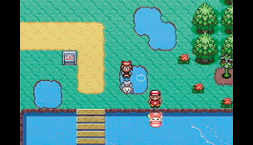
Pokémon Ruby and Sapphire are roleplay games developed by Game Freak published for the Nintendo Game Boy Advance in 2002. In these games, the player is controlled from an overhead, third person perspective, and there are 3 main screens, a map screen for when the user is exploring the world, a battle screen, and an inventory screen. When the player encounters a Pokémon, the battle screen is loaded, and a turn-based battle begins. Each turn, the player can either fight, attempt to catch the Pokémon, use an item, or flee. All Pokémon have HP, and when this reaches zero, the Pokémon faints and can no longer battle. When a battle is initiated, the Pokémon in the first slot of the user’s party is automatically chosen to battle. (Wikipedia , n.d.)
Image from Pokemon.com
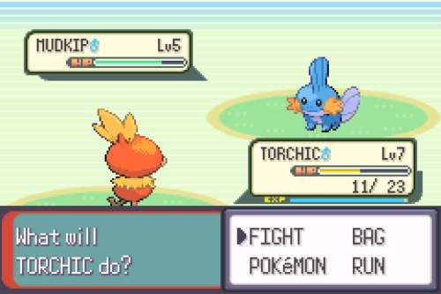
In the case that the player decides to flee from an encounter with a wild Pokémon (fleeing is not an option in trainer battles), the chance of a successful escape is calculated using the speed stat of the player’s active Pokémon, the speed stat of the wild Pokémon, and the number of times the player has previously tried to escape during this battle. (Bulbapedia, n.d.)
Image from gameuidatabase.com

When attempting to catch a wild Pokémon, the game uses a mathematical equation to produce a capture rate which is then used to decide whether the attempt will be successful. It uses the current and maximum HP of the wild Pokémon, the predetermined capture rate of its species, any status conditions it has, and the type of Pokéball being used. The equation used is $X=\left(\frac{\left(3M-2H\right)∙\left(C∙B\right)}{3M}\right)∙S$, where M is the maximum HP, H is the current HP, C is the species’ capture rate, S is the status condition, and B is the type of Pokéball. (The Cave of Dragonflies, n.d.)
The progression of the game is mostly linear, with events and plot points happening in a predetermined order. The player embarks on a journey to become the ‘Pokémon League Champion’ by beating all the gyms and then finally a team of four strong Pokémon leaders called the Elite Four. These Gyms serve as almost boss fights throughout the game, with perks being unlocked when each is defeated, such as new moves for your Pokémon or the ability to catch Pokémon of a higher level. (Wikipedia , n.d.)

I am going to take inspiration from the battle mechanics in order to implement something similar for my game, as I like the turn-based battles with the options to fight, use items, catch, or flee. When I implement the fleeing, I will implement RNG similar to the Pokémon franchise, in order to determine whether the escape was successful if the creature is not legendary. During an encounter with a legendary creature, the player can still choose to attack, or attempt to catch the creature, however fleeing is not an option for legendary encounters. Catching will also have a similar implementation, but there will not be different types of nets, and status effects will not affect the catch rate.
I am going to use a similar top orientated camera view, with inspiration from the design style. Also, Pokémon Ruby and Sapphire don’t use procedural generation and instead use static maps, which is something that I will do differently as my game will be procedurally generated in order to make the user experience more engaging and unique.
Furthermore, another feature I will do differently in my project is the storyline. Pokémon Ruby and Sapphire has a very structured progression through the game, with some areas being locked until certain objectives are completed, and a main storyline that changes very little, reducing the replayability. This is something that my project will solve as it offers a far less guided experience, with optional side quests that have little impact on the main experience.

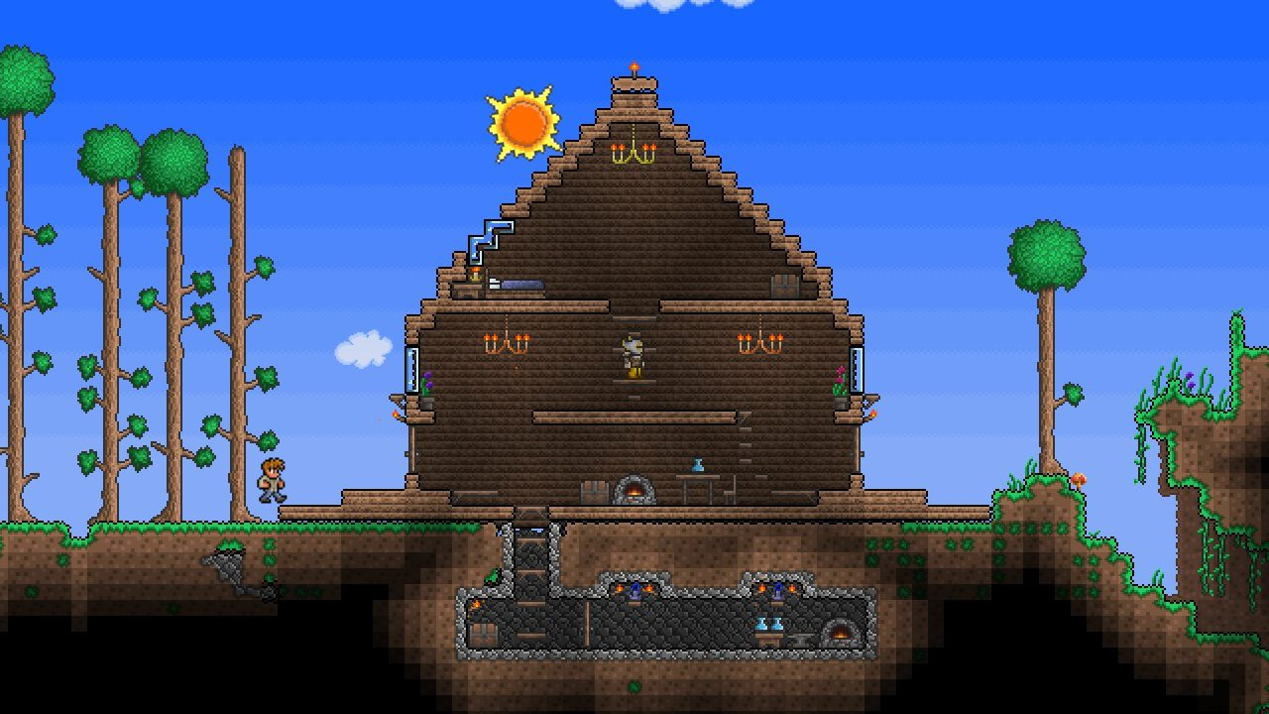
Area of Research 2 - Terraria
Image from www.ign.com
Terraria is a 2011 sandbox adventure game, in which the player explores a two-dimensional, procedurally generated world. The player can fight, explore, and craft, as well as engaging in boss fights and completing goals, some of which unlock access to items and services through NPCs. The game consists of retro style, side orientated graphics, with the world being divided into biomes, each of which having unique items and mobs. Players begin with low health and mana, which can be increased by completing various tasks. (Wikipedia, n.d.)
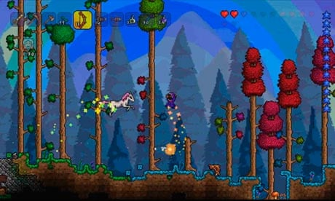
Whilst the game has no set goal or end outcome, there are various bosses that can be summoned and defeated by the player to obtain valuable items or advance the game slightly by introducing tougher enemies, for example. Also, by completing specific goals, the player can receive access to various NPCs which offer perks such as mining, healing, and fishing. (Wikipedia, n.d.)
Image from www.theguardian.com
The implementation for Terraria is also done predominantly in C#, using the open-source game engine MonoGame in later versions to facilitate cross-platform gaming. This will be similar to the implementation of my project, as I will be using C# code in visual studio and I am going to explore MonoGame as a possible platform. (Wikipedia, n.d.)
I am going to incorporate procedural generation into my project, specifically Perlin noise, which is the type that Terraria uses. Also, Terraria uses a similar sandbox nature to what I am going to incorporate into my project, with some goals having minor impact on the game, but there is no need to complete them in any particular order, nor a storyline which the player has to follow. Furthermore, I like the style of the graphics, and I am going to use a similar style of 2D pixilated sprites, however my game will be top orientated instead of side orientated.

Area of Research 3 – The Legend of Zelda: Breath of the Wild
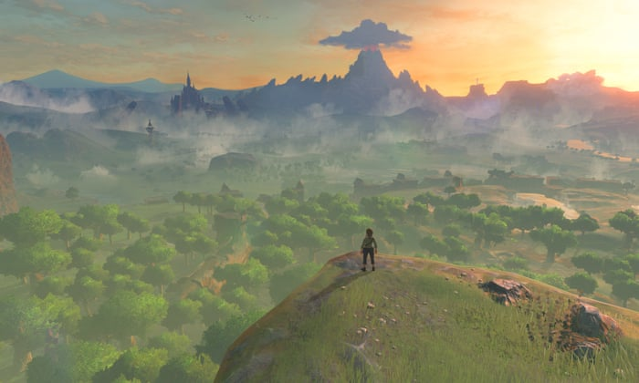
The Legend of Zelda: Breath of the Wild is an unstructured, open-world, action-adventure game which encourages exploration as the story can be completed in an order completely determined by the player as it is mainly progressed through objectives and side quests. There is minimal instruction or guidance given to the player, and they are instead encouraged to explore freely by the lack of “locked” areas or objectives with a unique solution. (Wikipedia, n.d.)
Image from www.theguardian.com
The main character, Link, awakens from a century-long slumber, finding that he has lost all of his memories, and he sets out on an adventure to retrieve them before it is too late. He must explore the vast and dangerous landscape of Hyrule using only the environment to produce items such as weapons, food, and other resources. He must scavenge to obtain food and cook meals which can replenish health and stamina or provide temporary status bonuses. (Wikipedia, n.d.)
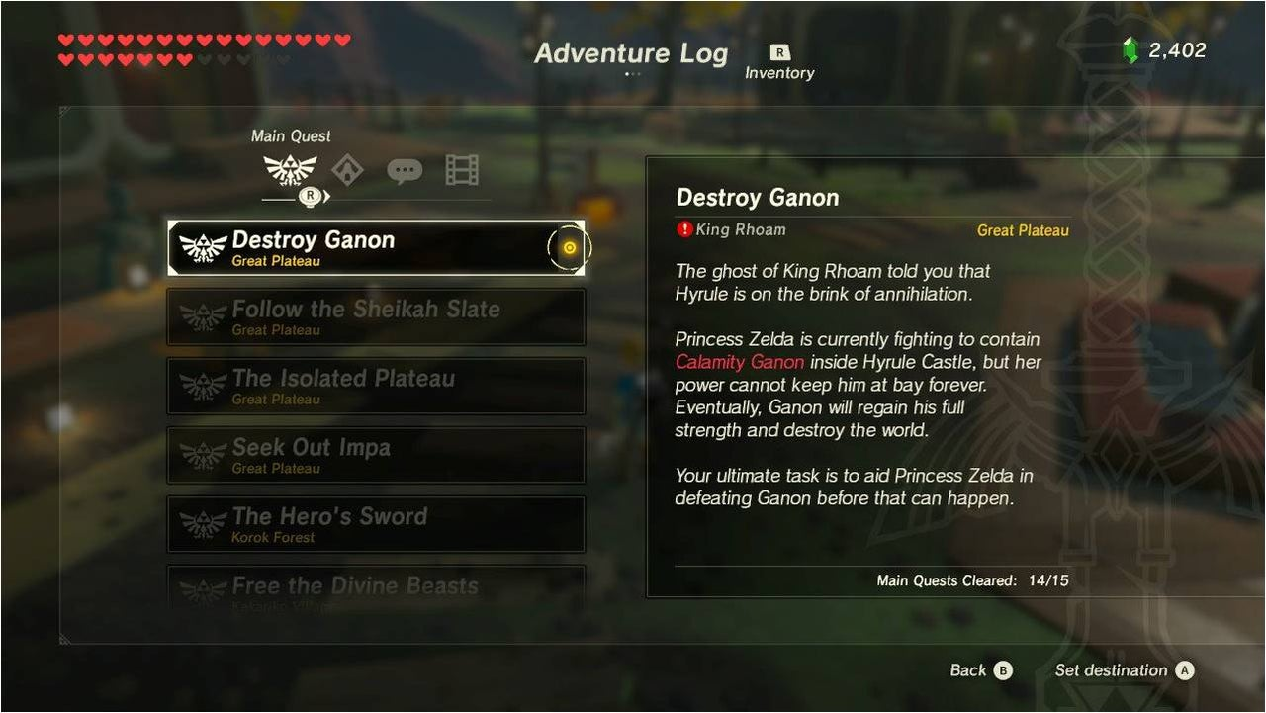
Image from www.ign.com
For my project, I am going to take a lot of inspiration from the sandbox nature of the game as this is something that is important to my client. This example is my biggest inspiration for that aspect as it widely renowned to be a landmark for open world sandbox games, being one of the bestselling video games ever. It was a pioneer for the open world genre of games, with a style that was relatively unique at the time of release.
Also, one of my favourite features is the nature of the storyline and objectives, where there is no pressing need to complete anything in a certain order or within a certain time frame, as this massively changes the gaming experience into something far more relaxing and leisurely. The quests are used in a quite unique way, with the purpose of teaching the player new features, instead of progressing the story in an extremely guided and slightly restrictive way.
Furthermore, the food and berries system is similar to how I will implement berries into my game. They will restore HP, remove status effects, and are able to give temporary status effects if used during a battle. However, instead of cooking meals, berries will be obtained from NPCs, and from the ground by exploring the landscape.

Initial Client Meeting
I formally met with my client in order to get a better idea of exactly what he wanted from my project.
- What features of existing creature-collecting or other types of roleplay games do you typically look for/find particularly interesting?
“I enjoy the different types of creatures and the collection aspect of it is the most fun part for me. For games such as Pokémon, the story is always the side quest for me and catching every type of creature is my main objective. After many years of playing very similar games, the storyline loses its importance, and I prefer the process of widening my collection because the storyline becomes repetitive in many games.”
- How do you feel about less story focused sandbox games?
“I like that there exists a mixture of both types of games but I prefer Legends of Zelda: Breath of the Wild and its sandbox nature much more than the older style of very guided games, although equally I really like some other quite linear games so it’s nice to have a balance of guidance and also ability to roam the world.”
- What elements do you feel that the existing game market is lacking?
“I feel like almost everything is covered in some way, shape, or form now, but some games don’t do certain features as well as I’d like. I would say that a lot of games try to fit too much in at once, and when you try to do everything a little bit, you don’t do anything well. I prefer when games start off small and develop a few things very well before expanding.”
- If you could design your dream roleplay game, what would you include?
“I really enjoy games with a big, open world that you are free to explore as you wish, and that’s something I’d definitely look to incorporate because I find the exploration very fun. Also, a good battle system is very important to me because I tend to get quite bored if the system isn’t very engaging. A lot of the games I played and really enjoyed were played when I was a bit younger so there is a sort of nostalgia aspect to a lot of the games I enjoy now too. I like the retro, nostalgic style of the old Pokémon games and the 2D pixelated style of games similar to Terraria.”

- Do you prefer turn-based battles or action-based combat?
“I think I definitely do prefer the turn-based style of combat but I’m not sure how much of that is through the sort of rose-tinted lens of nostalgia, although as I get older I still enjoy games with turn-based combat as I like that it’s more idle and can be done with one hand while you do something else. I feel as though a lot of the games I play with action-based combat feel less strategic and more as though the aim is to just push lots of buttons very fast which I’m not as much of a big fan of.”
- How do you feel about NPCs in video games?
“I enjoy being able to wander the world and speak to NPC’s dotted around, but equally I get quite frustrated when I’m hours into a game and I still feel like I’m having my hand held by tutorials that pop up at like 80 hours into the game. For this project, I would like to see something that hasn’t yet been done before using NPCs, for example if there were just one or two creatures in each area but it’s more of a process to find and catch them by talking to people and finding out things. I think the sort of “walk up to something, punch it in the head, throw a ball at it” thing has been exhausted a little and it would be very exciting to see something new and more involved.”
- What is more important to you in a creature-collecting game, catching as many creatures as possible or focusing on levelling up the ones you already have?
“I think the catching is far more fun, especially when you have a system where your team levels up naturally because manually going around to hunt XP gets quite boring quite quickly but I enjoy playing the game so it’s nice when the XP comes as a sort of bi-product of that. I also tend to get quite bored of certain creatures once they hit a very high level, especially when there’s a maximum level as it feels like wasted XP when I use them in battle as I know they cannot level up anymore.”

- Do you prefer games which have an “ending” when a certain objective is complete, or not?
“In Breath of the Wild, I really preferred the style of almost aimless wandering around, and I personally thought the ending was the worst bit because it wasn’t done too well. When a game has a very good storyline, I quite enjoy the end sequence a lot, but also, I really enjoy games with great post-game content, sometimes more than the main storyline. In Pokémon especially, I like the system of legendries and then the ability to wander around and finish catching all the creatures and completing things that you didn’t before, but also, I think if you’re going to do post-game content it has to be good. I’ve also played JRPG’s that have a very definitive ending where when the story is complete the game is just finished and I’ve also enjoyed those so I think it just depends on the execution but generally I’m a big fan of games where the ending has little impact and there’s a lot of good post-game content.”
- What causes you to lose/retain interest in a video game?
“A lot of the driving force into finishing games for me is that I’ve invested so many hours into it that I feel complied to see it through to the end, but I struggle to find a lot of time nowadays to finish games so I suppose it’s nicer when they don’t take hours upon hours to finish. Again, post-game content is very engaging and there are lots of games that I’ve spent hours playing after the main storyline is complete because I like the nature of the post-game content without the kind of pressure of completing the story. I tend to lose interest when you have too many characters in an RPG and I much prefer having just a few characters that are well developed and consistently pop up rather than loads and loads of shallow characters that you see once and then never again. Also, certain game loops can get a bit boring for me, but I suppose it depends on the game. Weirdly, I quite enjoy the process of creature collection games and I don’t tend to get bored of those even though it’s a lot of the same thing, but it would definitely be very fun to see a twist on the catching mechanism like we discussed earlier with the almost hunt for the creatures before you get to catch them.”

This interview was very useful for developing my ideas more and deciding exactly what my objectives will consist of as my client has helped by specifying exactly what he likes and dislikes in pre-existing games of a similar nature and also exactly what he would like to see in my project. I will definitely be incorporating the idea about the catching system as this would be a very fun twist on pre-existing creature-collection games with a good balance between a storyline and the ability to do whatever you please. I am going to add a few creatures which spawn in randomly around the world to give the user something else to have fun with other than the main storyline but there will also be certain legendary creatures that are slightly harder to catch as the encounter is preceded by a few objectives. However, the sandbox nature of the game will be retained as the player can be working towards completing multiple quests at the same time and there will be no predetermined order of which legendary creature must be caught first.

Objectives
- Users must be able to encounter and catch wild creatures.
- When the user interacts with a wild creature, a battle sequence is initiated.
- The user must be able to catch the creature.
    - Creatures are caught using nets, which can be obtained as loot from the map, bought from an NPC, or as rewards for completing quests.
    - The catch chance is determined by a mixture of RNG, berry effects, maximum HP, current HP, the level of both of the creatures, and the wild species’ catch rate.
    - When caught, the creature is registered to the user’s journal, which keeps track of which species they have encountered and obtained.
    - Once caught, the creature can either be added to the user’s party or stored away in the user’s bag. If there is an empty slot in the user’s party, the creature is automatically added to the party instead of the user being asked where they would like to send it.
- The user must be able to flee from the encounter (only if the creature is non legendary)
  - The flee chance is determined by a mixture of RNG, the level of the users’ creature, the level of the wild creature, and the number of previous escape attempts.
  - Once the user has fled from an encounter, the wild creature disappears off the map.
- Users must be able to battle wild creatures using their own party of creatures they have collected.
  - The party will consist of 5 creatures of the user’s choice, and these are the creatures that they can use in battle.
  - The creature in the first slot of the party will automatically be sent into battle when an encounter begins.
  - If the users party isn’t full (i.e. they haven’t obtained enough creatures at the start of the game), any creatures they obtain are automatically added to their party.
  - During a battle, when it is the users turn, they have the option to switch their active creature to a different one from their party.
  - When the user’s active creature faints, they get to choose another creature from their party to bring into battle.
- There will be five different types of creatures: fire, water, grass, magic and normal.
  - Each type of creature has moves exclusive to their type.
  - Normal creatures do not spawn in the wild, however the user is given a normal type creature at the beginning of the game as part of a short tutorial sequence.
  - Each type has weaknesses and strengths to other types.
    - A move that a creature is weak to will deal 1.5x damage.
    - A move that a creature is strong to will deal 0.75x damage.
    - Fire type is weak to water type and strong against grass type.
    - Water type is weak to grass type and strong against fire type.
    - Grass type is weak to fire type and strong against water type.
    - Magic type is weak to fire type and strong against normal type.
    - Normal type is weak to magic type and strong against nothing.
- There will be items with varying purposes that the user is able to scavenge from around the map and from NPCs.
  - There will be berries, nets, and potions all with varying purposes.
    - Nets are used for catching wild creatures.
    - Berries are used to make catching wild creatures easier and can also be used to cure status effects from the users’ creatures.
    - Potions are used to restore HP to the users’ creatures.
  - Items will spawn randomly around the map, and when a new chunk is generated, there is a random chance for an item to spawn along with it.
    - Users can interact with these items by clicking them.
  - Users can also obtain items from NPCs and objectives.
    - Some NPCs will give the user items upon interaction.
    - Some items are received from NPCs after a certain request has been fulfilled.
    - Some items are received straight to the user’s inventory after an objective has been completed.
  - The user can view what items they currently have as well as a brief description of each.
    - The user has a berry jar inside their bag which stores berries.
    - The user has a potion pot inside their bag which stores potions.
    - Nets and other miscellaneous items are stored inside the user’s bag.
  - The player can use an item during their turn in battle.
    - If a berry is used in an encounter with a wild creature, the creature becomes easier to catch.
    - Potions can be used in order to heal the user’s creature.
    - If an item is used during a turn, the user cannot also attack during this turn.
- There will be a legendary creature of each type that has enhanced stats and is more difficult to catch.
- The map will be procedurally generated and split into different biomes.
  - Each biome will have a type of creature native to it: grass type in meadows, fire type in volcanic fields, water type in lakes, magic type in magical forest.
  - Each biome will contain a legendary creature of its native type.
  - There will be NPCs in each biome which can be interacted with to unlock and complete objectives native to each biome.
- There must be a system to save and load progress.
  - Each user must have a save file to save their progress.

Modelling

Platform used
Monogame is an open-source C# library designed for 2D game development. It is also used for cross-platform game development and has been used in multiple well-known titles, such as Terraria and Stardew Valley. I considered this platform as it was used to develop one of the games that I researched and took inspiration from and also because I am already familiar with C# and Visual Studio as this is the language and platform I use at college. The use of a platform that I am already partially familiar with will allow me to put more of my time into developing my project rather than learning a new language or application.
Windows Forms, or Winforms, is an open-source GUI library for Visual Studio. It uses .Net framework so can also be written using C#. I have previously built projects using Winforms for college so I am relatively comfortable and confident using it already which, again, will let me focus more on the features of my project. Also, Winforms has previously been used to produce games similar to what my client wants and allows for features such as object tracking which will be useful in my game.
Pygame is a set of Python modules designed for writing fully functional games and projects. It is highly portable and runs on nearly every platform, which is a benefit for my project as it allows me to work on it wherever I am. It has a large wiki with lots of community support and also supports a lot of 2D graphics, including images, something that is important for my project due to the nature of the map. It also has a very easy system for implementing sound which could be useful if this is something I decide to add to my project at a later date. User inputs from the keyboard and mouse are easily handled which allows me to implement the movement fairly easily and gives me more time to tackle more complex aspects such as the map generation.
I have decided that I am going to use Pygame for my project because it has a high level of support for game making. After experimenting with all three platforms, I have decided that Pygame is the most suitable as it feels the most intuitive to me and is more portable than Winforms. Although I have less experience with Python than with C#, I have previously built projects using Pygame/regular Python and there is also a lot of support on the Wiki to assist me.

UI
There will be three different screens in the user interface: the open world map, the players inventory, and a battle/catching screen for when the player initiates an interaction with a wild creature. These are not final designs and do not illustrate exactly what the screens will look like in the final game, they are merely examples of my initial ideas.
Inventory:
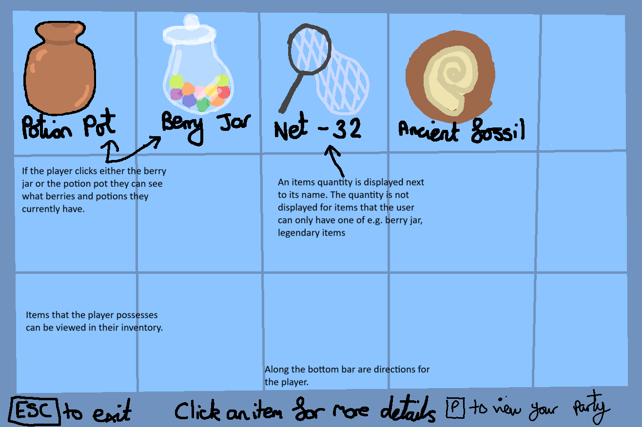
Battle screen:
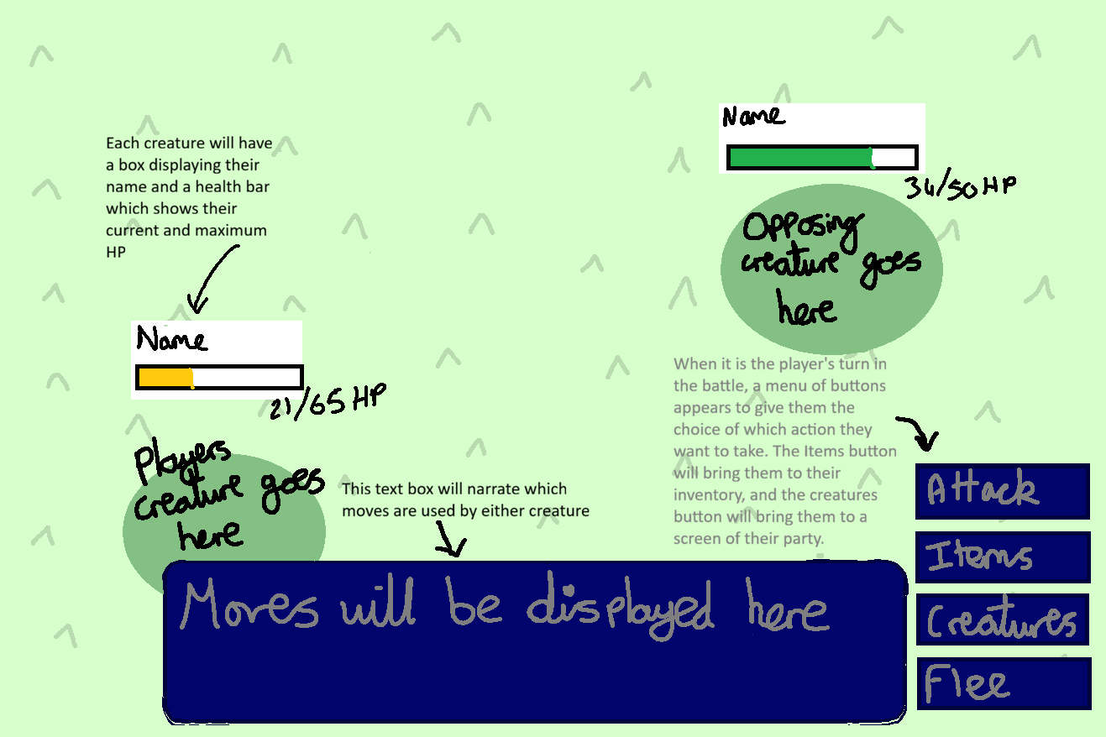
Main world map:
My map will be procedurally generated so each area will look different in each game save that the user creates, but the below image is an example of what a meadows biome could possibly look like.
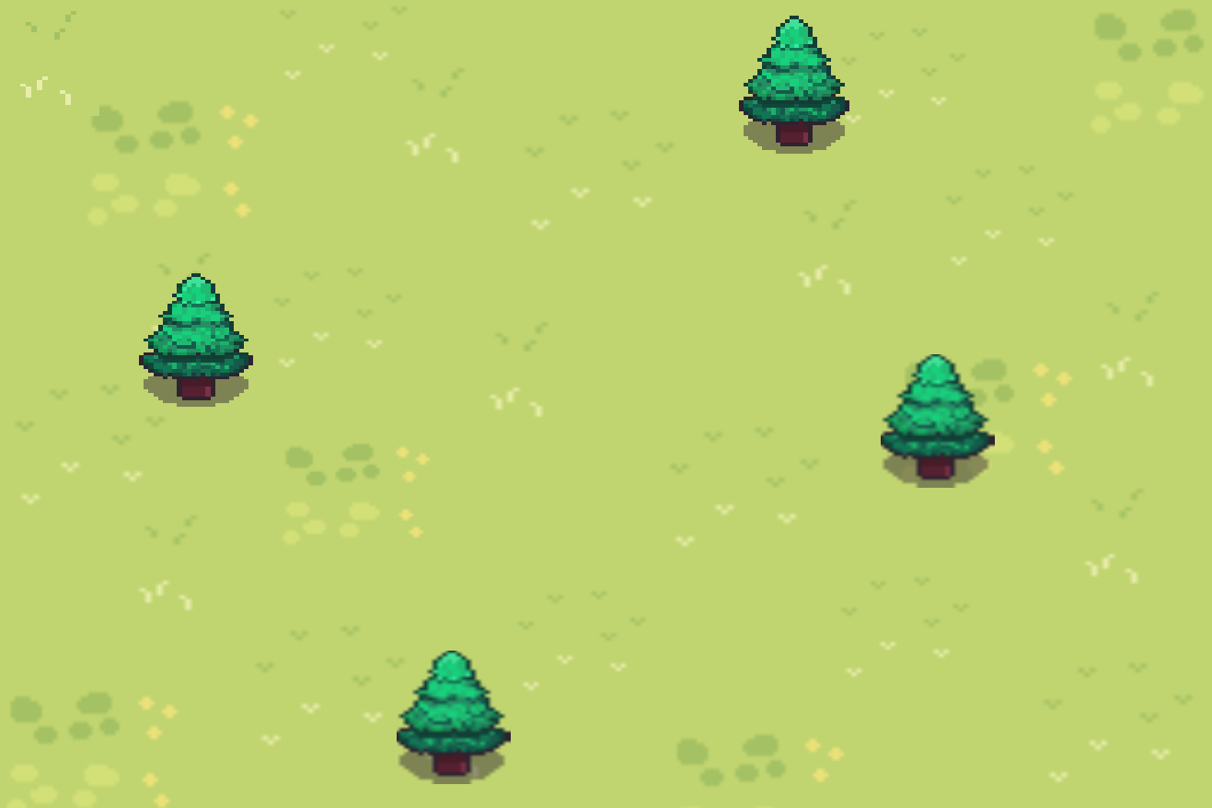
Grass tile sprites are from Pixelart Forest Top-Down RPG Asset Pack v2 by zedpxl on itch.io (itch.io, n.d.)
Trees sprite from 2D Top-Down Trees and Flowers by Lumi on itch.io (itch.io, n.d.)

Sprites
Creatures
All creature sprites and their names in this section have been generated by ChatGPT with the following prompt (I am developing a creature collecting role-play game inspired by the older Pokémon games and in a similar style to the artwork in Terraria. I have 4 types of creatures that appear in the wild which are fire, water, grass, and magic. There will also be a normal type starter creature given to the player during the short tutorial sequence at the beginning. There will also be one legendary creature for each type of creature except normal, with increased stats that is harder to catch. Please can you generate me the sprites for 2 creatures of each type, as well as one legendary for each type and two normal type creatures. I want them in a top-down pixel art style, partially inspired by real nature and partially fantasy. I would also like them to have a loose colour scheme by type (do not focus on this too much) with fire being red/orange, grass being green, water being blue and magic being pink. There is no colour scheme for normal type creatures. Please can you use an indie, pixel art style with quite muted colours where possible, nothing too bright. Please generate all of these sprites as one PNG image but do not make the sprites overlap or interact. thank you.) (Thanks, please would you also be able to give me names for each creature?)

Cinderlet | 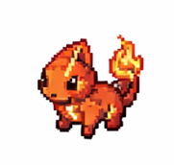 | HP: 50  Attack: 25  Defence: 15  Speed: 3  Catch rate: 0.7
Embergnaw | 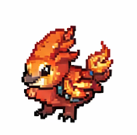 | HP: 70  Attack: 35  Defence: 15  Speed: 4  Catch rate: 0.5
Pyrocorv (Legendary) | 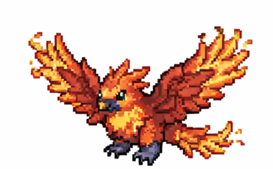 | HP: 120  Attack: 55  Defence: 35  Speed: 6  Catch rate: 0.4
Bubblit | 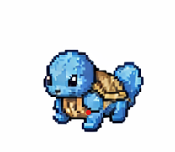 | HP: 55  Attack: 20  Defence: 15  Speed: 2  Catch rate: 0.6
Curlfin |  | HP: 75  Attack: 40  Defence: 25  Speed: 4  Catch rate: 0.6
Tideraik (Legendary) | 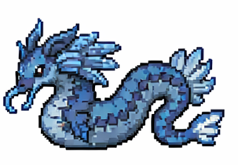 | HP: 125  Attack: 60  Defence: 40  Speed: 5  Catch rate: 0.4
Mossprig | 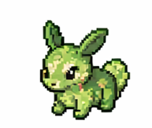 | HP: 35  Attack: 25  Defence: 20  Speed: 3  Catch rate: 0.7
Barkloon | 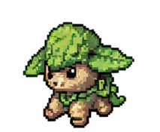 | HP: 55  Attack: 40  Defence: 30  Speed: 4  Catch rate: 0.6
Thornhart (Legendary) | 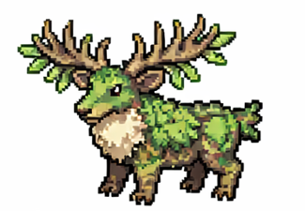 | HP: 110  Attack: 55  Defence: 44  Speed: 5  Catch rate: 0.4
Fayluff | 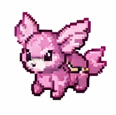 | HP: 50  Attack: 30  Defence: 25  Speed: 4  Catch rate: 0.7
Hexkit |  | HP: 60  Attack: 45  Defence: 35  Speed: 4  Catch rate: 0.6
Astravane (Legendary) | 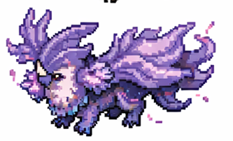 | HP: 130  Attack: 55  Defence: 60  Speed: 6  Catch rate: 0.4
Pufflin (normal – starter) | 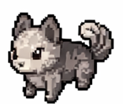 | HP: 45  Attack: 20  Defence: 15  Speed: 3  Catch rate: 1

Berries:
All berry sprites are retrieved from the Free Fruits and Berries - Pixel Pack 16x16 by Danaida on www.itch.io. (Itch.io, n.d.)
Buckthorn – restores 15HP to a creature or makes a wild creature slightly easier to catch.
Fig- restores 10HP and wakes up a creature that has been put to sleep.
Lychee – makes a sleeping creature easier to catch.
Strawberry – restores 20HP to a creature or makes a wild creature much easier to catch.
Potions
All potion sprites are retrieved from Potions by Onocentaur on www.itch.io. (itch.io, n.d.)
Weak brew – restores 20HP to a creature.
Medium brew – restores 50 HP to a creature.
Strong brew – restores 80 HP to a creature.
Special brew – revives an unconscious creature and restores 100HP.

-Speech bubble for NPC dialogue. Retrieved from Pixel Speech Bubbles by Aspecs Gaming on itch.io (itch.io, n.d.)

Details of health/abilities
Each creature has a type, either fire, water, grass, magic, or normal. The only normal creature will be given to the user during the short tutorial at the beginning of the game and there will be no other normal creatures that spawn in the world. Each type of creature can perform moves native to its species as well as a few normal type moves. Each creature will have its own set of 4 moves that do not change. Types have weaknesses to each other, with weak types dealing 0.75x damage and strong types dealing 1.5x damage. Strengths and weaknesses are detailed in the below chart:
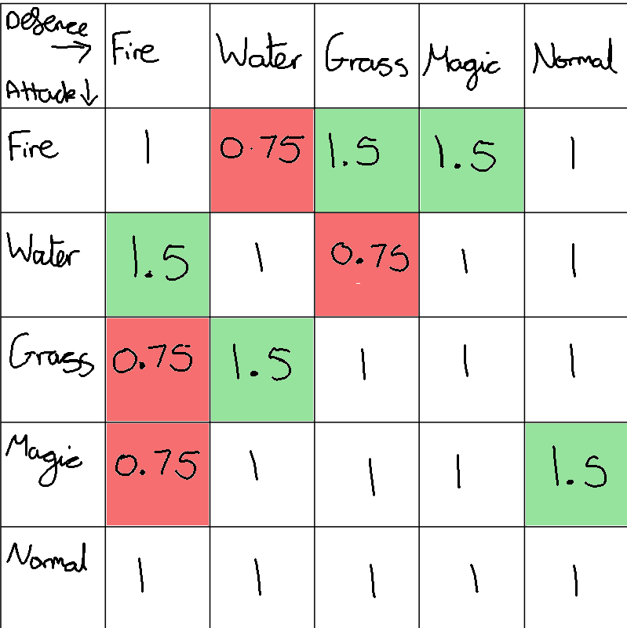
Typed moves:
The “damage” in the section below refers to the base damage of the move, it can change based on the user's level and attack stat as well as the opponent’s level and defence stat.
Fire
- Flame beam – 40 damage.
- Ash rain – 35 damage
Water
- Bubble beam – 35 damage.
- Tsunami – 50 damage
Grass
- Flower beam – 35 damage
- Bloom – restores the users health by half the damage inflicted. 40 damage
Magic
- Fairy dust – puts the target to sleep for a turn so they cannot attack. 25 damage
- Light beam – 45 damage
Normal
- Slap – 30 damage.
- Tackle – 35 damage.
- Bite – 40 damage.
- Tail whip – can only be used by creatures with a tail (Pufflin, Hexkit, Fayluff, Mossprig, Tideraik, Curlfin, Bubblit, Cinderlet). 30 damage
- Mad-rage – the user takes half as much damage as what has been inflicted on the opposing creature. This can only be learnt by legendary creatures. 60 damage.

Details of levels and XP
Each creature will start at level 1 with base stats native to their species as detailed above in the Sprites section. Creatures will be able to level up after obtaining a certain amount of XP. The guide below shows how many experience points are required to move up a level.
Levels 1-5: 150XP
Levels 5-10: 200XP
Levels 10-20: 300XP
Levels 20-30: 350XP
Levels 30-40: 400XP
Levels 40-50: 450 XP
Levels 50+: 500XP
Each time a creature earns experience points, the player is notified, and if they have accumulated enough XP to level up, the player is also notified of this. When increasing levels, each of the creatures’ stats (attack, defence, speed, HP) will increase by a random number 1 to 3. Catch rate stays constant as the level of the creature is separately taken into account during the calculation for catching. There is no maximum level that a creature can reach, as this is something that my client has said that he wants to be included because maximum levels cause him to lose interest in certain creatures because it feels like wasted XP.
XP can be gained from various sources, such as catching wild creatures, defeating wild creatures in battle, and completing quests. There is bonus XP for catching a new creature for the first time and the XP gained from battles is also dependent on the level difference between the player’s creature and the opposing creature. If the opposing creature has a higher level than the player’s creature, the player’s creature will receive more XP, however if its level is much lower, the player’s creature will earn significantly less XP. The creature in the player’s active spot when the opposing creature is either defeated or caught receives double the amount of XP as all the other creatures in their party, and any fainted creatures only receive half the amount of XP as they would if they were conscious. Catching legendary creatures yields more XP than regular creatures.

UML Diagram
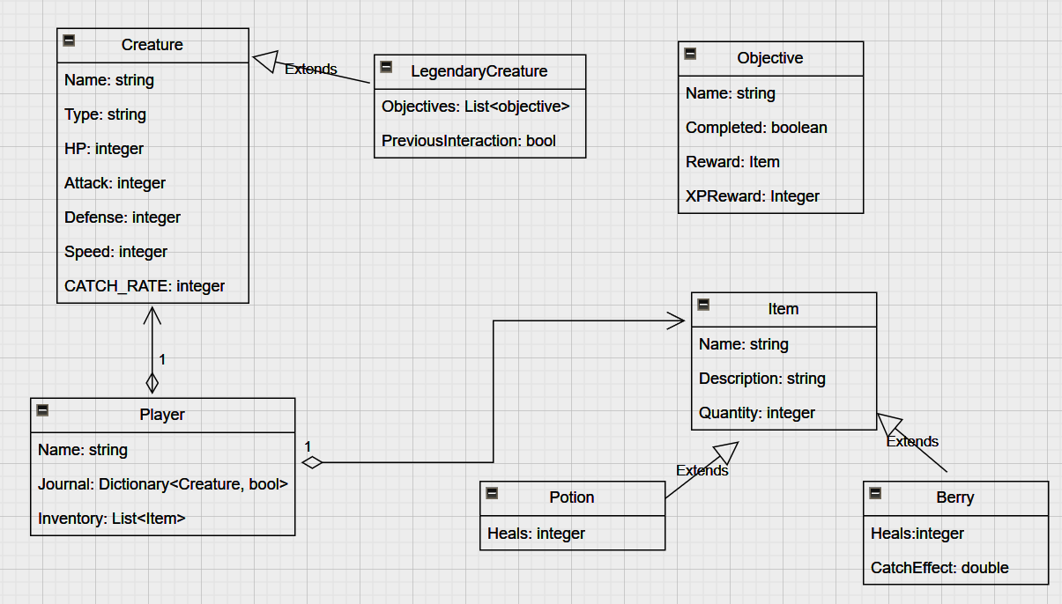

Client Meeting – Objectives
My client was presented with my modelling and initial list of objectives, and he said that it looked good and he was excited to see the final product.
Is there anything that you want to be included that you feel I have missed out in my modelling/objectives?
“I think most of it looks really good, but I think it would be good to have some kind of base camps scattered around the map that the player can visit when they want to heal their creatures as it stops them from having to use all their potions and berries all the time. I also think you need a system to buy potions and nets from an NPC at the base camp as well as from the world because at the moment it’s a bit too difficult to obtain items which may make the user start to lose interest if the game becomes too difficult. I don’t think you should be able to buy berries though, I think it’s better when you have to scavenge the map for those.
I like the sprites a lot, and I think the creatures are great, especially the way that there’s only a few of each type because it’s clear you followed my advice about preferring games that don’t try to accomplish too much and instead start smaller and focus on getting those aspects perfect. However, the only worry I have is that it looks very unnatural when the sprites are completely stationary, especially during battle. Even if they just bobbed up and down, I would much prefer that to them being completely still because it ruins the immersion for me.
In terms of type matchups, fire is more powerful than any other type because it is strong against both grass and magic which could be seen as slightly unfair by some players. I think it would be good to consider that just because, for example, fire is strong against magic, magic type moves don’t necessarily have to deal less damage to fire type creatures. To resolve this, you could possibly have normal type be strong against magic, I don’t think that normal type moves have to be completely neutral. Or perhaps you could have magic type being weak to itself, so magic moves deal increased damage to magic type creatures.”
Would you prefer when you have only one chance to catch a legendary creature or do you want the player to be able to have as many interactions as they need before they catch it?
“I suppose there’s always the option of saving before interacting with the legendary and then resetting your save if you aren’t successful, but I would definitely like it if you had multiple chances because it reduces the stress of having to get the encounter right the first time and adds to the relaxing feel of the game. It would be good if once all the players creatures faint, the screen fades to black, and then the player wakes up back at the last base camp they visited where they have all their creatures restored back to full health and are free to try again. I don’t think the user should have to complete all the quests again but maybe it would be fun to have the legendary move to a different location in the biome so it’s not too repetitive if they have multiple attempts and it still adds a bit more fun through the hunt for creature as well as a chance to level up their creatures during their exploration before a second attempt.”
You mentioned something about manual saving, is that something you’re more interested in or do you prefer games that auto-save?
“I think I definitely prefer manual saving, maybe some of that is just because all the games I grew up playing had it, but I also like the idea that you can manually save before doing certain things like interactions with creatures so if you do something wrong or don’t get the outcome you wanted, you can just reset the game and go back to the previous save before you did it. Also, I think the files section of your objectives list needs to be more in depth.”

Final Objectives List
Changes from my initial objectives list are given in Pink.
- Users must be able to encounter and catch wild creatures.
- When the user interacts with a wild creature, a battle sequence is initiated.
- The user must be able to catch the creature.
  - Creatures are caught using nets, which can be obtained as loot from the map, brought from an NPC, or as rewards for completing quests.
  - The catch chance is determined by a mixture of RNG, berry effects, maximum HP, current HP, the level of both of the creatures, and the wild species’ catch rate.
  - When caught, the creature is registered to the user’s journal, which keeps track of which species they have encountered and obtained.
  - Once caught, the creature can either be added to the user’s party or stored away in the user’s bag. If there is an empty slot in the user’s party, the creature is automatically added to the party instead of the user being asked where they would like to send it.
- The user must be able to flee from the encounter (only if the creature is non legendary)
  - The flee chance is determined by a mixture of RNG, the level of the users’ creature, the level of the wild creature, and the number of previous escape attempts.
  - Once the user has fled from an encounter, the wild creature disappears off the map.
- Users must be able to battle wild creatures using their own party of creatures they have collected.
  - The party will consist of 5 creatures of the user’s choice, and these are the creatures that they can use in battle.
  - The creature in the first slot of the party will automatically be sent into battle when an encounter begins.
  - If the users party isn’t full (i.e. they haven’t obtained enough creatures at the start of the game), any creatures they obtain are automatically added to their party.
  - During a battle, when it is the users turn, they have the option to switch their active creature to a different one from their party.
  - When the user’s active creature faints, they get to choose another creature from their party to bring into battle.
- There will be five different types of creatures: fire, water, grass, magic and normal.
  - Each type of creature has moves exclusive to their type.
  - Every type of creature can use normal type moves.
  - Each creature has a randomly allocated set of 4 moves.
  - Normal creatures do not spawn in the wild, however the user is given a normal type creature at the beginning of the game as part of a short tutorial sequence.
  - Each type has weaknesses and strengths to other types.
    - A move that a creature is weak to will deal 1.5x damage.
    - A move that a creature is strong to will deal 0.75x damage.
    - Fire type is weak to water type and strong against grass type.
    - Water type is weak to grass type and strong against fire type.
    - Grass type is weak to fire type and strong against water type.
    - Magic type is weak to other magic type creatures.
    - Normal type is neither weak nor strong to any other types.
- There will be items with varying purposes that the user is able to scavenge from around the map and from NPCs.
  - There will be berries, nets, and potions all with varying purposes.
    - Nets are used for catching wild creatures.
    - Berries are used to make catching wild creatures easier and can also be used to cure status effects from the users’ creatures.
    - Potions are used to restore HP to the users’ creatures.
  - Items will spawn randomly around the map and when a new chunk is generated there is a random chance for an item to spawn along with it.
    - Users can interact with these items by clicking them.
  - Users can also obtain items from NPCs and objectives.
    - Some NPCs will give the user items upon interaction.
    - Some items are received from NPCs after a certain request has been fulfilled.
    - Some items are received straight to the user’s inventory after an objective has been completed.
  - The user can view what items they currently have as well as a brief description of each.
    - The user has a berry jar inside their bag which stores berries.
    - The user has a potion pot inside their bag which stores potions.
    - Nets and other miscellaneous items are stored inside the user’s bag.
  - The player can use an item during their turn in battle.
    - If a berry is used in an encounter with a wild creature, the creature becomes easier to catch.
    - Potions can be used in order to heal the user’s creature.
    - If an item is used during a turn, the user cannot also attack during this turn.
- There will be a base camp in each biome that contains an NPC.
  - This NPC can heal the player’s party of creatures.
    - It will restore their maximum HP as well as remove any status conditions that they may have.
  - The players can buy and trade items with the NPC.
    - There will be a currency system of coins, and the player can trade in items from their inventory for coins or buy items with their coins.
    - Coins can be obtained from battles and objectives.
    - Certain items cannot be traded, such as items needed to interact with legendary creatures.
  - If the player loses a battle, they will awaken at their last visited base camp.
- There will be a legendary creature of each type that has enhanced stats and is more difficult to catch.
  - The player can only initiate an interaction with a legendary creature after completing certain objectives and obtaining a specific item.
    - The player must track down this item by completing requests from various NPCs.
    - Pyrocorv requires a fossil.
    - Tideraik requires a sea stone.
    - Thornhart requires an ancient flower.
    - Astravane requires a magical flute.
  - If the player loses a battle with a legendary creature, the creature will move to a different location, and the player can attempt to catch it again after finding it.
  - The player can attempt to catch the legendary creature before making it unconscious, but if it gets knocked out first, a catching sequence is initiated.
    - Once in the catching sequence, the player can continue trying to catch the creature until they succeed.
- The map will be procedurally generated and split into different biomes.
  - Each biome will have a type of creature native to it: grass type in meadows, fire type in volcanic fields, water type in lakes, magic type in magical forest.
  - Each biome will contain a legendary creature of its native type.
  - There will be NPCs in each biome which can be interacted with to unlock and complete objectives native to each biome.
    - These objectives are structured around finding the designated item for each legendary creature.
- There must be a system to save and load progress.
  - Each user must have a save file to save their progress.
    - There will be 3 available save slots, each with the player’s name and the time and date of last save displayed to allow the user to identify saves.
    - If an empty save slot is chosen, the game will create a new save file.
    - If a pre-existing save is chosen, the game will load that save file and allow the player to resume from where they last saved.
  - The save file will store data about the user’s creatures, inventory, journal, and name.
  - The player must manually save their progress through their inventory.

Design

Prototype
Static map in file. 3 creatures for battle and catch. 1 legendary with 1 quest. Items will need to be there but not necessarily all of them.

Structure Diagrams

Algorithms

ERD (if database)

User Interface

Data Structures

File Organisation (if files)

Perlin Noise implementation

Technical Solution

Testing

Evaluation

References
(n.d.). Retrieved from Wikipedia : https://en.wikipedia.org/wiki/Pok%C3%A9mon_Ruby_and_Sapphire
(n.d.). Retrieved from Bulbapedia: https://bulbapedia.bulbagarden.net/wiki/Escape
(n.d.). Retrieved from Wikipedia: https://en.wikipedia.org/wiki/MonoGame
(n.d.). Retrieved from Wikipedia: https://en.wikipedia.org/wiki/Terraria
(n.d.). Retrieved from Wikipedia: https://en.wikipedia.org/wiki/The_Legend_of_Zelda:_Breath_of_the_Wild
(n.d.). Retrieved from The Cave of Dragonflies: https://www.dragonflycave.com/mechanics/gen-iii-iv-capturing/#:~:text=Throwing%20a%20Ball-,Catch%20Rate%20Calculator,B)3M)%E2%8B%85S
(n.d.). Retrieved from Itch.io: https://danaida.itch.io/fruits-and-berries-pixel-pack-16x16
(n.d.). Retrieved from itch.io: https://onocentaur.itch.io/potions
(n.d.). Retrieved from itch.io: https://aspecsgaming.itch.io/pixel-speech-bubbles

